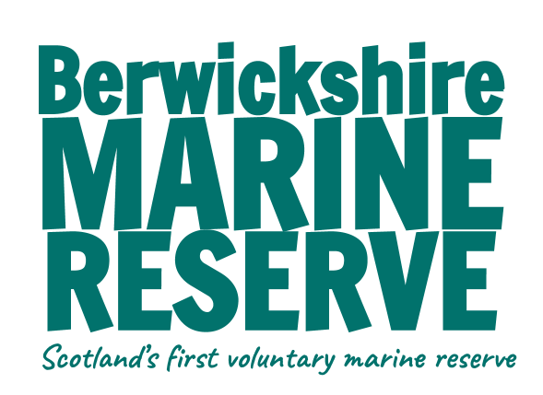

Part Three - The Ocean is a Climate Hero. Teacher notes

Powerpoint - use as an introduction to this section. Activities / Experiments can be completed after each section, or the powerpoint presentation can be done as a whole and then activities to follow.

Activities: These can be tailored to suit either First / Second Level, KS1/KS2 or individual class needs.

From the smallest to the largest
- Use the internet to find out facts about Phytoplankton and diatoms - make a diatom fact sheet.
- Draw a diatom - known as the jewels of the sea, draw your own beautiful and symmetrical diatom
- Create a food chain using the animal cards in worksheets. Start with phytoplankton and work your way up the food chain. This shows how phytoplankton is vitally important.
- Food web activity

- Whale art - as a class make a life size picture/model of a whale
- Make a whale factsheet / research whales that are found locally.
- Whale art - make a paper plate whale or origami whale

Practical
- Experiment - find the plankton
- Whale watching trip to coast (this can be a citizen science project - report findings to local group or national - WDC or Seawatch)

Forests of the Sea
- Make a poster of a kelp forest / seagrass meadow / mangrove forest / salt marsh highlighting the different life that this supports and it’s importance as a carbon sink. Divide class into 4 groups - each group making a poster for one habitat. (see below for examples and info to aid research) https://www.thebluecarboninitiative.org/about-blue-carbon
- OR write an article for school or local newspaper describing the importance of ‘blue carbon’ habitats.
- Research local / national / international restoration efforts eg:
https://www.wwf.org.uk/scotland/restoration-forth
https://www.projectseagrass.org/
https://www.seawilding.org/
https://sussexwildlifetrust.org.uk/helpourkelp
Using seagrass to fight the climate emergency | WWF
https://www.essexwt.org.uk/what-we-do/protecting-wildlife/projects/saltmarsh
https://www.unesco.org/en/mab/mangres
- Write to your local MP to encourage them to support blue carbon initiatives
https://members.parliament.uk/FindYourMP - UK
https://www.parliament.scot/msps - Scotland
https://senedd.wales/find-a-member-of-the-senedd/ - Wales

Nature’s Defences
- Experiment - Seagrass: Nature’s Defence.

Renewable Energy
Info sheet and worksheet alongside this BBC Bitesize lesson
- If possible arrange a visit to a renewable energy facility, or a talk by a representative
- Think about the pros and cons of this type of energy - class debate

