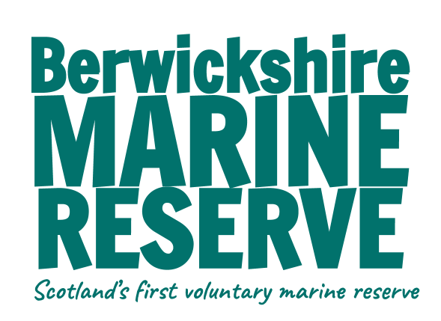

Part Two - How is the ocean affected by climate change? Teacher notes

This section looks at the effects of climate change on our seas, the problems that are created and the consequences of these for the planet.

Powerpoint - as an introduction to this section, start with the powerpoint which can then lead on to the following activities. Experiments for this section can be done throughout the powerpoint presentation after each relevant slide, or afterwards.

Rising sea temps
This section examines the two factors that are causing sea levels to rise - thermal expansion and melting ice.

All levels
- The thermal capacity of water can be examined either by watching the video as part of the powerpoint or by doing the balloon experiment yourself in class.
- Water balloon experiment Oceans of Climate Change
This shows how water has a huge capacity for absorbing heat. 90% of the excess heat created by global warming is absorbed by the oceans.

Two experiments can follow looking at different causes of sea level rise.
- Sea level rise through thermal expansion. Experiment to be done in class.
Learning Space: How Warming Water Causes Sea Level Rise
- How melting ice causes sea level rise.
Learning Space: How Melting Ice Causes Sea Level Rise - YouTube
- Choose a local / well known coastal area and view on this map, what parts will be underwater by 2050 (or further in the future) if no changes are made to how we behave.

For Second Level / KS2
- Imagine you are in local government for your area/a chosen area, and are dealing with the problem of rising sea levels. Draw up a flood plan for the area. What would need to move, where would it go, how would this be financed? What new defences would you build? Use the internet to research some existing solutions in other parts of the world
(eg: https://www.weforum.org/agenda/2022/08/rising-sea-levels-global-adaptation/)

Marine heatwaves
Second Level / KS2
- Watch this video explainer of the 2023 marine heatwave phenomenon in the UK
- Info sheet and worksheet

Ocean Acidification
Use slide / worksheet to explain acidity and alkalinity.
Using PH paper measure the ph levels of some household liquids.
Conduct experiment using coral skeleton or sea shells (land snail shells would work if sea shells not available.)

Ocean Currents
For Second Level / KS2 only - quite complicated ideas for younger children beyond explaining that our weather is driven by ocean currents and climate change can alter this. Although experiments are appropriate for younger children.

For older children see this video BBC Conveyor Belt which explains the process well.
- Info and worksheet.
- In 2004 the film ‘The Day after Tomorrow’ dramatised the imagined breakdown of the Global Ocean Conveyor Belt. Show the trailer to show an exaggerated example of how important the deepwater current is. (the film itself is rated 12)
- Experiments: Water density experiments and ocean zones jar.

Classroom Activities

- Coral Reef Drawings
Using black paper and poster paint - put a blob of paint onto the paper - use a straw to blow the paint into shapes resembling coral. Use different colours, explore different shapes. Once the paint has dried you can add sea creatures to your coral reef.

- Jenga
Using a jenga tower game. The complete jenga tower represents a healthy ocean with wide ranging biodiversity.
One by one the children take a card, read what is on the card and decide if this action has a positive or negative effect on climate change and our seas.
For a positive action, do nothing - move to the next player. For a negative action remove a block from the tower.
Too many negative actions and the tower will collapse. This demonstrates that a healthy ocean cannot thrive while these climate change caused problems are ongoing.

Practical Activities

- Big Seaweed Search (this looks for seaweeds affected by sea temp rises and ocean acidification). Citizen Science - data is recorded by MCS and Natural History Museum.

- Intertidal monitoring or rockpooling can be a good way of assessing the health of a local coastal area. A large number of varied species will indicate a healthy biodiversity. Monitoring this over time can help highlight the effects, if any, of climate change on the intertidal population.
A full scientific survey would prove quite difficult for this age group of children, but a rockpooling session with a purpose - counting the life found - can be a good introduction to scientific techniques and the idea of biodiversity. (see activity sheet)
PLEASE FOLLOW OUR CODE OF CONDUCT FOR ROCKPOOLING
A useful identification guide can be found here or purchased here.

