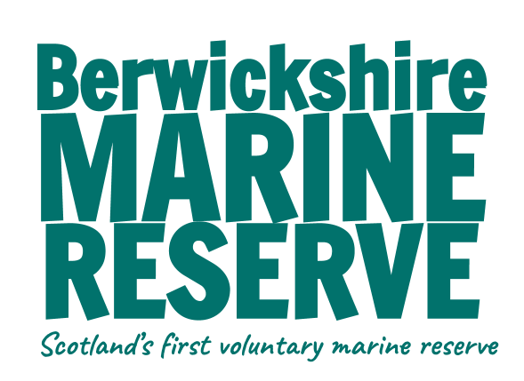

APPLICATION FOR SUMMER MARINE RANGER POSITION

Please complete and send to info@berwickshiremarinereserve.org.uk

SURNAME:
FORNAME(S):
ADDRESS:

POSTCODE:
DATE OF BIRTH:
DAYTIME TELEPHONE:
EVENING TELEPHONE:
MOBILE TELEPHONE:
EMAIL:

FULL DRIVING LICENSE (Valid in UK)
DETAILS OF ANY POINTS OR PREVIOUS DRIVING CONVICTIONS
DO YOU HAVE A CRIMINAL RECORD
IF YES PLEASE GIVE DETAILS (since we work with local schools “spent” convictions must also be detailed)
DATES AVAILABLE TO WORK BETWEEN

DATA PROTECTION: The information you have provided will be kept confidential.
EDUCATION

FROM | TO | SCHOOL/INSTITUTE | SUBJECTS TAKEN | QUALIFICATIONS GAINED

SKILLS AUDIT: Please tick appropriate boxes and give more information where appropriate

SKILLS, EXPERIENCE | CERTIFICATED | COMPETENT | BEGINNER | NONE | MORE INFORMATION
Wildlife ID e.g. intertidal spp., birds, cetaceans

Biological Monitoring/ survey work

People skills

Visitor liaison

Leading or assisting with guided walks/ events

Data Handling/ input

Communications e.g.
Graphic Design, Photography & Videography

IT skills

First Aid

Other

PLEASE FEEL FREE TO CONTINUE ON A SEPARATE SHEET IF REQUIRED FOR THE FOLLOWING QUESTIONS

Please give us details of your hobbies/interests:
Please outline any nature conservation/rangering or other relevant work/voluntary experience:
What would you hope to gain, and what do you feel you could offer working at the BMR?
Any other information which may be useful or important:
Please give us details of two people who may be contacted as referees:
Name:  Relationship:  Email: | Name:  Relationship:  Email:
How did you hear about this position?

SIGNATURE: DATE: _________________

